CRM Project

Functional Specification - Enhancement

CRM.PP6.CM-090-090-100-E.CM_ENH_140 - Contract Mgmt_ALLConnect/Ebill

(Object ID: CM_ENH_140)

Deliverable Name | PP6 Enhancement Functional Specifications
Date | 11/19/10
Revision | V3.0
Signed off By
Signoff Date

TABLE OF CONTENTS

1. Version 3
2. Approvals 3
3. Priority Mention the Priority of the object from the FRICEW list in ILM. Processing Mode (check all that apply) 3
Low Medium High 3
4. Enhancement Requirements Description 3
5. Impacted Systems 4
6. Approach to be followed < List the type of enhancement whether it is a user exit, BADI or Custom transaction> 4
7. Roles and Volumes 5
8. Security & Control Requirements - NA 5
8.1 Security Requirements 5
8.2 Control/Audit Requirements - NA 5
9. Dependencies 5
9.1 Development Dependencies 5
9.2 Run/Execution Dependencies 6
9.3 Archiving Dependencies 6
10. Execution Steps 6
10.1 Process Description 6
10.2 Process Flow 6
10.3 As-Is Systems Referred To 7
10.4 Processing Options 7
11. Enhancement Description 7
11.1 Detailed Description of the Enhancement 9
11.2 UI Design and Screen Flow < Mention the WEBUI Design in the sense the mock up screens and the navigation flow between the screens etc> 20
11.3 Access Method or Path for Enhancement 20
11.4 Required Custom Tables (if known) - NA 20
11.5 Error Handling Rules 21
12. Enhancement Reconciliation & Testing Requirements 22
12.1 Data Validation 22
12.2 Testing Reconciliation - NA 22
12.3 Performance Issues - NA 22
13. Additional Information - NA 22
14. Open Items 22
15. Functional Unit Test cases <Here they should list the possible test scenarios in the table below> 22
The eBill presentment parameter = N and AllConnect parameter = N 23
The eBill presentment parameter = Y and AllConnect parameter = Y 24

Version
Ensure that any approved change requests that affect scope are documented in the revision history and include CR #.
Version | Change Description | Author | Date Released | Sections Impacted
Enter in the version number | Brief description of the change | Who made the change | Date change was made | Mention the sections impacted with this change
1.0 | Initial creation | Cecilia Shepherd | 11/8/10
2.0 | Changed the Security Requirement for viewing the AllConnect questionnaire. | Cecilia Shepherd | 11/19/10 | 8.1
3.0 | Changed references to system error message to error message.  Provided explanation on changing UME password.  Corrected the execution of the UME password reset.  Provided clarification on the Spanish-speaking customer/transfer rule.  Rewrote FUT section. | Cecilia Shepherd | 01/04/11 | 11.1 and 15

Approvals
The individuals listed below will be required to review and approve this document.
Reviewers Title | Reviewer Role | Name
Project Title of Reviewer | Reviewer's Role (Responsible, Approve, Consult, Inform) | Reviewer's Name
CRM Functional Team Lead | Approve | Robert Smeltekop
Technical Team Lead | Approve | V. Krishna Karunakaram

Priority
Mention the Priority of the object from the FRICEW list in ILM.
Processing Mode (check all that apply)

Low Medium High

Enhancement Requirements Description

<This section should contain a detailed description of the business requirements for this enhancement in business terms. Please insert any description of the business flow which would aid in understanding this process.>

The system will navigate to the Questionnaire view from the Contract Management Create Contract process framework based on the eligibility rules for the eBill presentment and All Connect questionnaire. The buttons for each questionnaire will be enabled only if it passes the eligibility rules.

- eBill presentment: The purpose of this enhancement is to allow the CSR to offer the customer an eBill option while they have them on the phone performing a create contract.

If it passed the eBill Presentment eligibility, eBill button will be enabled and the list of questions will be presented immediately. The agent can then enroll or not enroll the customer for eBill.

If the customer chooses to enroll for eBill, an email from ECC will be sent to the customer.

If the customer has a new email address, the UME or OCS profile will be updated with the new email address.

- All Connect: The purpose of this enhancement is to allow the Agent to choose to transfer the call to Allconnect or to provide a reason for not transferring the call.

If it passed the All Connect eligibility, the AllConnect button will be enabled and the list of questions will be presented immediately after the agent clicks on the Finish button on the eBill Presentment or it will present the AllConnect questionnaire immediately upon navigating to this view if the eBill Presentment questionnaire is not enabled.

If the customer chooses to be transferred to AllConnect, the CSR will then transfer the eligible customer’s phone call to Allconnect for additional services. It is also required that the customer’s data is sent to Allconnect just prior to the CSR transferring the call.

Table, ztfo_allcon_log in ECC will updated to capture the information gathered from the AllConnect Questionnaire.

The agent has to either enroll or not enroll the customer on either the eBill presentment or the All Connect before leaving the Questionnaire view, otherwise, the agent will get an error message.

Impacted Systems

<This list should include systems that are being impacted as a result of this enhancement.>

CRM 7.0 Web IC : CRM 7.0 Web Client Interaction Center Production System
ECC 6.0 / IS-U ECC 6.0 / IS-U : Back End Production System (Enterprise Central Component)

Approach to be followed
< List the type of enhancement whether it is a user exit, BADI or Custom transaction>

A new view will be developed to present the eBill presentment and All Connect questionnaires.

Roles and Volumes
<Describe information regarding users and volumes. Make sure to note if the use of this development will require additional communication and/or training. Also, specify what the volume requirements will be needed by the Go-Live date.

Complete the table below with the correct project-specific information for this functional specification. Instructions are in the middle row, and a sample entry is in the bottom row.>
Role | Estimated Volume Requirement | Comments
List name of role; should come from the list of security roles | Enter the estimated volume requirements that will be needed by the Go-Live date | Enter other comments including if this development will require additional communication and/or training
 | 821,617 move-in documents for 2009

Security & Control Requirements - NA

Security Requirements
<Describe any security requirements that need to be put in place as a result of this development object. This could include security access to affected transactions or new transactions that may result from this development. If the enhancement has to be archive enabled, list additional security to be added to the roles.> NA

Most move-ins are handled by CSR2, therefore eBill presentment are also handled by CSR2s. However, a CSR2 cannot reset a UME password.

Only CSR2 and CSR3 are allowed to view the AllConnect questionnaire.

Control/Audit Requirements - NA
<Describe any control requirements that need to be put in place as a result of this development object>.
- If applicable, please answer the question and also provide detail to the question.
- The questions listed below are not all inclusive to the control requirement that may be required. If there are any other controls requirements please document them as well.

- Indicate if this enhancement is being developed to address a control requirement?
- Financial/SOX Impact - Does the enhancement have any impact to financial reporting? If yes, is the amount significant (i.e. greater than $35 million annually)? Please provide an estimate. No
- Regulatory Impact - Does the enhancement have any impact to regulatory compliance (i.e. FERC, NERC, etc)? If yes, please provide a reference to the rule and describe the impact. No
- Operational Impact - Is the enhancement relied upon for a mission critical process or providing services to customers? If yes, please identify the mission critical process and describe how this enhancement is used in the context of this process.

Dependencies

Development Dependencies
<List the configuration, development, and other work that must be considered during the creation of this enhancement.>

CRM.PP6.CM-090-090-090-E.CM_ENH_190 - Contract Mgmt_Create Contract Summary

Run/Execution Dependencies
<Once in production, this development object may need to be executed before or after another system event. List other system events that this development object should follow or precede. If the enhancement is to be archived enabled, does it need to have adequate archived sessions, info structures, etc established in order to test/execute.>
N/A

Archiving Dependencies
<List how the changes would impact archiving, if the enhancement impacts existing archived objects (i.e. table structures). Also list what needs to be regression tested from an archiving perspective.>

Execution Steps

Process Description
<Explain the process for when this development object will be used. If this is tied back to a certain task within a process you may insert the Task Profile document here as well.

Enter any of the following information available:
- Transaction Code
- User Exits
- Performance Consideration
- Z Tables created
- Code reuse.

The system will navigate to the Questionnaire view from the Contract Management Create Contract process framework based on the eligibility rules for the eBill presentment and All Connect questionnaire. The buttons for each questionnaire will be enabled only if it passes the eligibility rules.

Process Flow
<Create a diagram that visually depicts the process.>

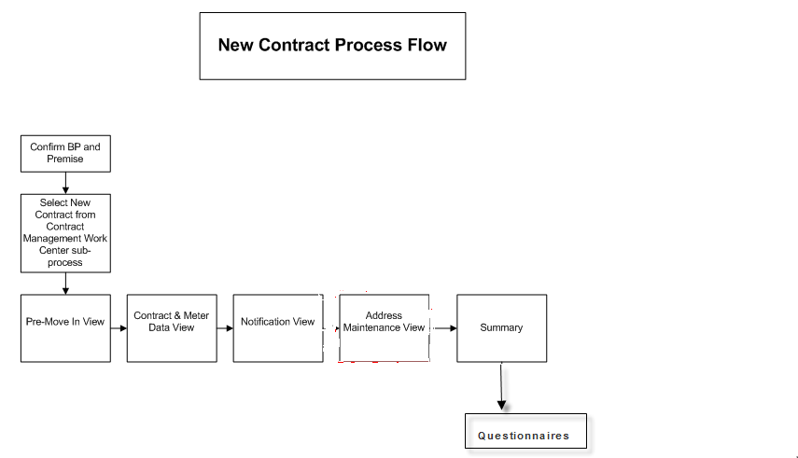

As-Is Systems Referred To
<List the systems that the task pertaining to this development object is performed in. If this is a new task (i.e. not being performed today), list it ‘Not applicable’.>

Execute CICO in ECC, Select Create Move-in (ZMOVE-IN) front office process.

Processing Options
<Indicate the Processing Mode, Frequency, and Lifetime of Development by selecting and placing an ‘X’ in the box next to the correct options below. Right click on the gray box, select properties, and specify “Checked”.>
Processing Mode (Select one of the following)
Batch Online – via Transaction Code Online – via Menu Path
On demand

Frequency (Select one of the following)
Daily
Weekly Quarterly
Monthly Annually
Other (If other, describe here)

Lifetime of Development (select one)
Permanent
Temporary, e.g. until rollouts are complete, specify details here

Enhancement Description
<Provide a brief description of the enhancement.>

The system will navigate to this view after the SUBMIT button is pressed from the Contract Management Summary view and it will receive the following parameters:

- eBill parameter
- AllConnect parameter
- Business Agreement
- Contract document number
- BP number
- Premise address (street, city, state, zip code)
- Premise number
- BP default phone number

The Questionnaire view will be dependent on the value of eBill parameter and AllConnect parameter to determine the enablement of the eBill Presentment Questionnaire and AllConnect Questionnaire buttons.

If the eBill Presentment Questionnaire and the AllConnect Questionnaire are both enabled, present the list of eBill Presentment questions first. Otherwise, present the list of AllConnect Questionnaire.

- eBill Presentment:

Present the eBill questionnaire.

When the agent clicks on the Finish button, it must validate whether the agent either enrolled or not enrolled the customer.

If the agent did not make a selection to either enroll or not enroll the customer
It must give an error message: ‘Please choose an option to enroll or not enroll the customer for eBill’ and do not allow the agent to navigate to the All Connect questionnaire until the agent makes a selection to either enroll or not enroll the customer. Do not allow the agent to navigate to another view until the agent corrects the error
Else
Navigate to the AllConnect questionnaire if the button for the AllConnect Questionnaire is enabled.

- AllConnect:

Present the AllConnect questionnaire.

When the agent clicks on the Finished button

if the agent selected ‘N’ for Transfer Customer, it must validate whether the agent selected a reason for not transferring the call.

If the agent did not select a value from the drop down list of reasons for not transferring the call
It must give an error message: “Please select a reason for not transferring the call to All Connect”. It must not allow the agent to navigate to another view until the agent corrects the error.

If the agent selected ‘Y’ to Transfer Customer, it must call the interface, FO_INT_250, to transfer the data to AllConnect. The agent can then press the Transfer button from telephony bar in CRM IC Web.

Detailed Description of the Enhancement
<Provide a written description of the functionality that needs to be developed. Identify/describe the SAP application transaction that uses or is used to invoke the enhancement. Describe tables, transactions, reports, forms, screens and other objects that need to be created or modified. Insert a Visio flow diagram of the process to be executed by the enhancement, and add any other information required to develop the enhancement.>

The system will navigate to this view after the SUBMIT button is pressed from the Contract Management Create Contract process framework and It will receive the following parameters:

- eBill parameter
- AllConnect parameter
- Business Agreement
- Contract document number
- BP number
- Premise address (street, city, state, zip code)
- Premise number
- BP default phone number

The Questionnaire view will be dependent on the value of eBill parameter and AllConnect parameter to determine the enablement of the eBill Presentment Questionnaire and AllConnect Questionnaire buttons.

If the eBill Presentment Questionnaire and the AllConnect Questionnaire are both enabled, present the list of eBill Presentment questions first. Otherwise, present the list of AllConnect Questionnaire.

- eBill Presentment:

a.1 Determine the if the business partner has a UME or OCS profile in the UCES system.

a.2 Present the eBill questionnaire.

If the customer has a UME profile in the UCES system
Present eBill questionnaire 1
Else
If the customer has no UME or OCS profile
Present eBill questionnaire 2
Else
If Customer has an OCS profile in the UCES system
Present eBill questionnaire 3.

a.1 eBill Questionnaire 1 for customer’s with UME Profile

- Present this view:

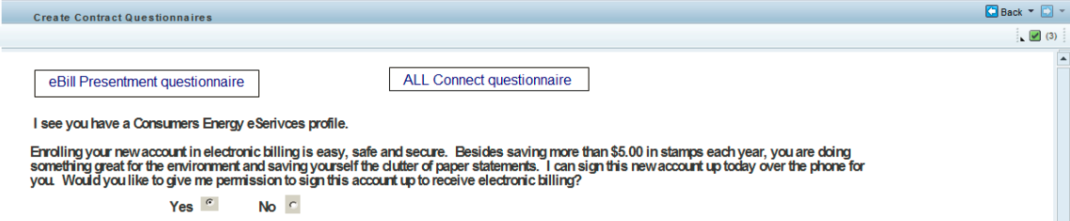

- If the agent selects the radio button Yes, present this view:

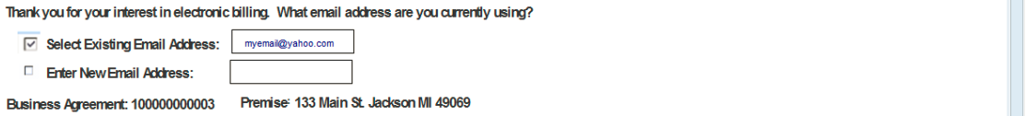

- If there is an existing UCES Email address, the Select Existing Email Address must have a check as the default selection and the email address from the UME profile must be automatically entered in the Select Existing Email Address field. This field must be non-editable.

- Display the Business Agreement and Premise address (non-editable)

- Followed by the following view, where it should populate the email address with the email address that was selected by the agent:

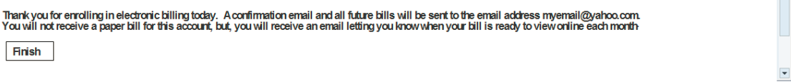

- Set the email notification flag = Y in the business agreement table

- Set the paper bill notification flag = blank in the business agreement table

- Set the message equal to the following for the Interaction Record Notes with text type = System Notes
“eBill Enrollment Accepted UCES Profile”

- Pass the business agreement in the Interaction Record’s activity clipboard

- Set class = ZCUS, action code = EBED, and pass the business agreement number for contact management

Else if the agent selects the radio button No

- Present this view.

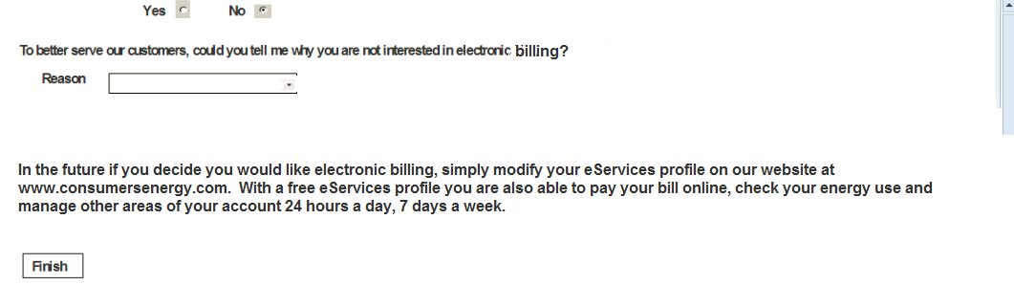

Where the reason field should have the following drop down list values:

  - Paper Bill Reminds me of my Bill Due Date
  - No Computer or not regularly on the Internet
  - I don't have a personal email address
  - I have Security Concerns
  - I Like Paper Bills for My Records
  - The Enrollment Process is Too Complicated
  - Email Request
  - Landlord/3rd party Request

- Set the email notification flag = N in the business agreement table

- Set the paper bill notification flag = check in the business agreement table

- Set the message equal to the following for the Interaction Record Notes with text type = System Notes:
“eBill Enrollment eServices Profile Decline”

- Pass the business agreement in the Interaction Record’s activity clipboard

- Set class = ZCUS, action code = EBUD, pass business agreement and the reason for decline (notes) in contact management

a.2 eBill Questionnaire2 (No profile)

- Present this view:

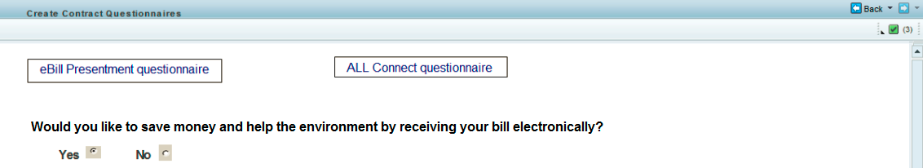

- If the agent selects the radio button Yes

  - Present this view:

  - Once the agent enters the new valid email address, present this view where the email address is populated with the new email address and the account number with the business agreement number:
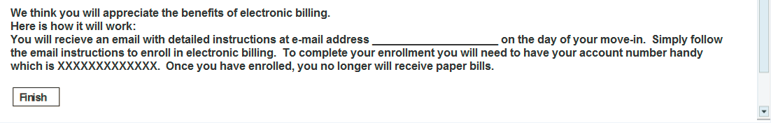

  - Set the email notification flag = Y in the business agreement table

  - Set the paper bill notification flag = blank in the business agreement table

  - Set the message equal to the following for the Interaction Record Notes with text type = System Notes
  - “eBill Enrollment New Account Pending”

  - Pass the business agreement in the Interaction Record’s activity clipboard

  - Set class = ZCUS, action code = EBNP, pass business agreement and the reason for decline (notes) in contact management

- If the agent selects the radio button No

  - Present this view:

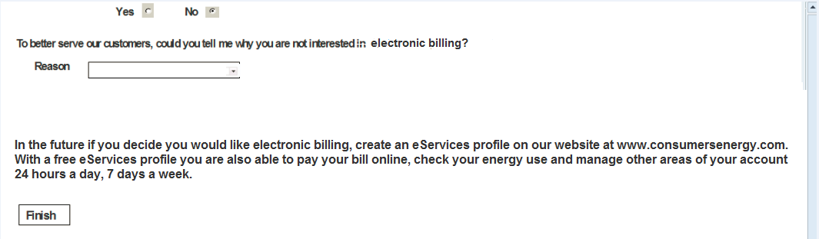
Where the reason field should have the following drop down list values:

- Paper Bill Reminds me of my Bill Due Date
- No Computer or not regularly on the Internet
- I don't have a personal email address
- I have Security Concerns
- I Like Paper Bills for My Records
- The Enrollment Process is Too Complicated
- Email Request
- Landlord/3rd party Request

- Set the email notification flag = N in the business agreement table

- Set the paper bill notification flag = check in the business agreement table

- Set the message equal to the following for the Interaction Record Notes with text type = System Notes
“eBill Enrollment No Profile Decline”

  - Pass the business agreement in the Interaction Record’s activity clipboard

  - Set class = ZCUS, action code = EBND, pass business agreement and the reason for decline (notes) in contact management

a.3 eBill Questionnaire 3 for customer’s with OCS profile

- Present this view:

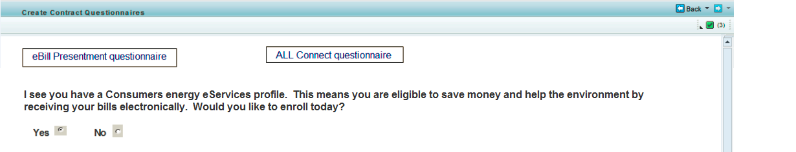

- If the agent selects the radio button Yes

  - Present this view:

  - If there is an existing UCES Email address, the Select Existing Email Address must have a check as the default selection and the email address from the eService profile must be automatically entered in the Select Existing Email Address field. This field must be non-editable.

- Display the Business Agreement and Premise address (non-editable)

- Followed by the following view, where it should populate the email address that was entered by the agent, where the email address is populated with the email address that was selected by the agent (either new or existing) and the account number is the business agreement number:

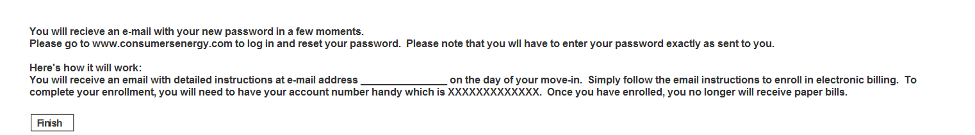

- Set the email notification flag = Y in the business agreement table

- Set the paper bill notification flag = blank in the business agreement table

- Set the message equal to the following for the Interaction Record Notes with text type = System Notes
“eBill Enrollment OCS Account Pending”

  - Set class = ZCUS and action code = EBOP for contact management

- A customer with an OCS profile had a Consumers Energy online account prior to the CEA SAP go live. As part of the conversion an online profile was created for these customers but they have NOT logged in since go live and accepted the new terms and conditions. The CSR must execute the UME Define Initial Password. The following pop-up message will be displayed if the customer with an OCS profile access eBill presentment.

Present the following Pop-up message after the agent clicks on the FINISH button.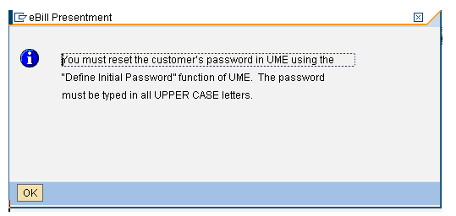

- If the agent selects the radio button No

  - Present this view after the agent click on OK button from the pop-up:

Where the reason field should have the following drop down list values:

        - Paper Bill Reminds me of my Bill Due Date
        - No Computer or not regularly on the Internet
        - I don't have a personal email address
        - I have Security Concerns
        - I Like Paper Bills for My Records
        - The Enrollment Process is Too Complicated
        - Email Request
        - Landlord/3rd party Request

  - Set the email notification flag = N in the business agreement table

  - Set the paper bill notification flag = check in the business agreement table

  - Set the message equal to the following for the Interaction Record Notes with text type = System Notes
    - “eBill Enrollment OCS Profile Decline”

  - Pass the business agreement in the Interaction Record’s activity clipboard

    - Set class = ZCUS, action code = EBOD, pass business agreement and the reason for decline (notes) in contact management

When the agent clicks on the FINISH button in any of the eBill Presentment views:

  - It must validate that the agent made a selection on either the Yes or No radio button. If the agent did not select either a Yes or No on the radio button, display the following error message: Please choose an option to enroll or not enroll the customer for eBill’

  - If the Enter New Address was selected, it must check that the new email address is not blank and that a valid email address has been entered. If the agent did not enter any value in this field, display the following error message: Please enter a valid email address.

If the email address is correct, it must update the existing UME or OCS profile with the new email address. If the customer does not have a UME or OCS profile, update the dependent and independent address of the Business Partner information in CRM.

- Create system note on the Interaction Record with text type = System notes

- Create a Contact Management record in ECC with the values set for Class and Action code on each of the views.

- Update the business agreement with the values set in the email notification flag and the paper notification flag.

- If a new email address was created update the UME or OCS profile.

- If email notification flag is set to “Y” perform an RFC call to Z_MI_EBILL ENROLL to generate the email. Set the email notification flag = Y in the business agreement table.

- Set the message equal to the following for the Interaction Record Notes with text type = System Notes

  - If the AllConnect button is enabled, navigate to the AllConnect questionnaire else navigate to the Account Identification view.

- AllConnect:

Present the AllConnect questionnaire.

b.1 Transfer

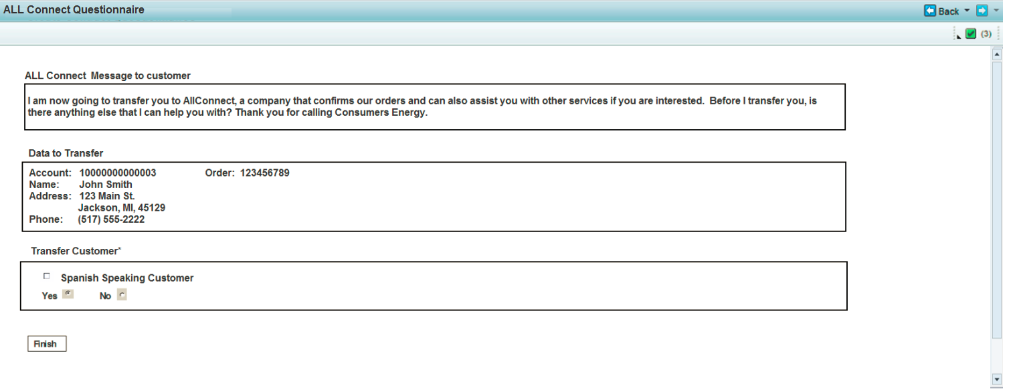

- The first assignment block contains a static message:

- The second assignment block contains the following non-editable data to be transferred to AllConnect:

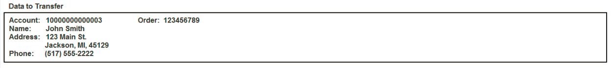

Where:
- Account = Business Agreement
- Name = Business Partner name
- Address = Premise Address
- Order = Contract number
- Phone = BP default phone number

- The agent must make a selection in the Transfer Customer assignment block. The Yes radio button must be selected as a default:

- If the agent clicks on Yes, it should not display the Reason dropped down list box.

- If the agent clicks on the Spanish Speaking Customer, Yes should be the default for the transfer. The agent should not be able to select No.

B2. Decline Transfer

If the agent clicks on the No button.
- Display the following the drop down list box for reason why the customer was not transferred

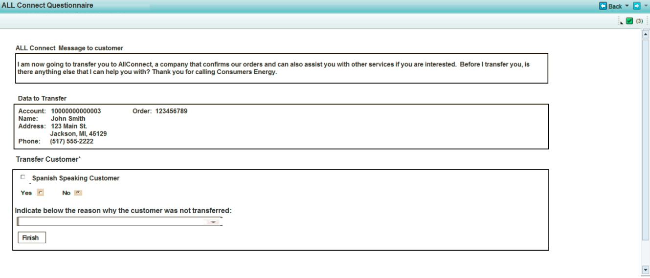

- The Reason drop down list box should be displayed. The following are the values in this drop down list box:

- NCC/Email/Fax/Correspondence
- Landlord/Builder/3rd Party
- Coaching Review
- Call Back – Order Update
- ASP Sale Confirmation
- Back Office

C. When the agent clicks on the Finish button in the All Connect Questionnaire:

- If the agent selected ‘N’ for Transfer Customer, it must validate whether the agent selected a reason for not transferring the call.

- If the agent did not select a value from the drop down list of reasons for not transferring the call
It must give an error message: “Please select a reason for not transferring the call to All Connect”. It must not allow the agent to navigate in another view until the agent corrects the error.

- Call the interface to AllConnect, FO_INT_250 and pass the following parameters:

- It will also store the following data in the Z-Table, ztfo_allcon_log, in ECC

- Set the Creation date (DATS 8) = system date
- Set the Creation time (TIMS 6) = system time
- Set the BP number (char 10) = BP number passed from the Contract Summary view
- Set the Move in document number with the Contract document number (char 12)
- Set the Action flag (If the rep selects a reason not to transfer set action flag to 0. If the rep transfers the call then set action flag to 1.
- Set the Rep’s SAP ID (char 12) with the SAP user id
- Set the Reason (char 40) with the value selected from the Reason drop down list box

- Navigate back to the BP Identification view

UI Design and Screen Flow
< Mention the WEBUI Design in the sense the mock up screens and the navigation flow between the screens etc>

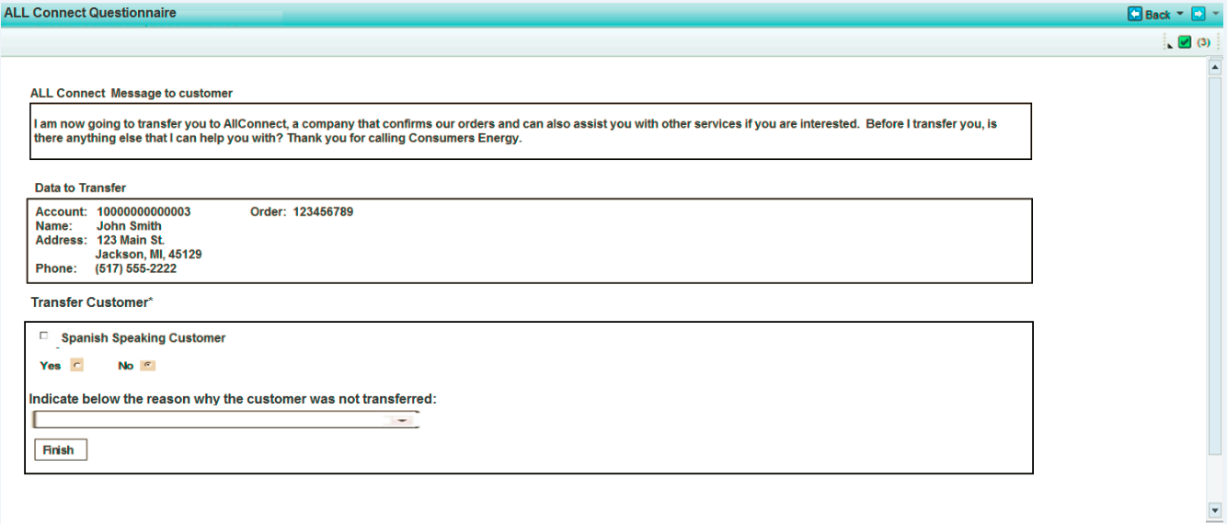

Access Method or Path for Enhancement
<Select the correct execution path below by placing an ‘X’ in the checkbox next to it and completing the description that follows. Check all that apply and add any other execution methods if required by the Client. Right click on the gray box, select properties, and specify “Checked”.>
Execution: Custom Transaction Code:
Menu Path:
Standard Transaction Code:
Other: The system will navigate to this view after the agent clicks on the SUBMIT button on the Contract Management Summary view.

Required Custom Tables (if known) - NA
<Provide any information about custom tables required for this enhancement.>
Table Name: Enter Table Name
Table Description: Enter Table Description
M/O | Field Description | Type (text or numeric) | Maximum Field Length | Value Restrictions? | Validations?
Mention M if the field is mandatory and O if the field is optional | Enter the field description | Enter the type | Enter the max. field length | Enter any value restrictions | Mention if any validations are required or else mention NA

Error Handling Rules
<Explain what the error handling rules would be if there are any for this development. For example, if an enhancement is scheduled to be printed and it does not, what should a user do to get this corrected?>

- If the agent did not make a selection to either enroll or not enroll the customer
Set the error message to ‘Please choose an option to enroll or not enroll the customer for eBill’ and do not allow the agent to navigate to the All Connect questionnaire until the agent makes a selection to either enroll or not enroll the customer. Do not allow the agent to navigate to another view until the agent corrects the error.

- if the agent selected ‘N’ for Transfer Customer, it must validate whether the agent selected a reason for not transferring the call.
If the agent did not select a value from the drop down list of reasons for not transferring the call
Set the error message to “Please select a reason for not transferring the call to All Connect”. It must not allow the agent to navigate to another view until the agent corrects the error.

- When the agent clicks on the FINISH button in any of the eBill Presentment views:

  - It must validate that the agent made a selection on either the Yes or No radio button.

  - If the agent did not select either a Yes or No on the radio button,

Set the error message to “ Please choose an option to enroll or not enroll the customer for eBill’

  - If the Enter New Address was selected, it must check that the new email address is not blank and that a valid email address has been entered.

If the agent did not enter any value in this field,
Set the system error message to “Please enter a valid email address”

else
Update the existing UME or OCS profile with the new email address.

Enhancement Reconciliation & Testing Requirements

Data Validation
- How will data using the enhancement be validated (e.g. compare reports, control totals etc.)?

The values for the following parameters that were passed from the Contract Management Summary view, should have the same values that were received by the Questionnaire view:

- eBill parameter
- AllConnect parameter
- Business Agreement
- Contract document number
- BP number
- Premise address (street, city, state, zip code)
- Premise number
- BP default phone number

- Is regression testing required from an SAP Data Archiving perspective? NA

Testing Reconciliation - NA
- Who will test the enhancement?

Performance Issues - NA
- Any potential issues on performance – for archived enabled enhancements?

Additional Information - NA
<Enter any additional information that could be helpful in developing this enhancement.>

Open Items
<This includes Risks and Issues logged in Clarity and Action Items.>
Item # | Detailed Description | Proposed Solution
Insert number | Describe the item | Describe the proposed resolution

Functional Unit Test cases <Here they should list the possible test scenarios in the table below>
Test Condition Description | Input Data | Expected Results | Actual Results/Comments
The eBill presentment parameter = N and AllConnect parameter = N |  | The system should not navigate to the Questionnaire view.
If the eBill presentment parameter = Y and AllConnect parameter = N, |  | The eBill presentment should be enabled and the AllConnect button should NOT be enabled.  The system should navigate to the Questionnaire view and display the eBill presentment questionnaire.  The system should navigate to the Account Identification view after the agent clicks on the Finish button and there are no errors.
The eBill presentment parameter = N and AllConnect parameter = Y, |  | The eBill presentment should NOT be enabled and the AllConnect button should be enabled.  The system should navigate to the Questionnaire view and display the AllConnect questionnaire.  The system should navigate to the Account Identification view after the agent clicks on the Finish button and there are no errors.
The eBill presentment parameter = Y and AllConnect parameter = Y |  | The eBill presentment and the AllConnect button should be enabled.  The system should navigate to the Questionnaire view and display the AllConnect questionnaire.  The system should navigate to the AllConnect questionnaire after the agent clicks on the Finish button in the eBill Presentment view and there are no errors.  The system should navigate to the Account Identification view after the agent clicks on the Finish button in the AllConnect view and there are no errors.

- eBill Presentment testing scenarios:

- Customer has UME profile,

  - Validate that the static message has the following:

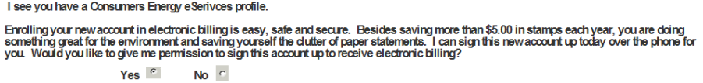

  - Select ‘Yes’ for eBill Presentment
    - Validate that the following is presented in the view:

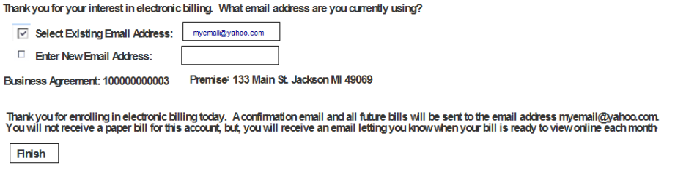

    - The system should populate existing email address with the email address from the customer’s UME profile in the UCES system
    - The business agreement and Premise address should be the same as the business agreement that was passed from the Contract Management Create Contract process framework.
    - The agent enters a valid new email address, the system should update the customer’s UME profile.
    - Click on the Finish button.
      - The Interaction Record should have the following value in the Notes view with text type = System Notes : eBill Enrollment Accepted UCES Profile. The business agreement should be in the activity clipboard.
      - The system should have created a record in Contact Management in ECC for the BP, where the
        - Set class = ZCUS, action code = EBED, and it has the business agreement number
      - The system should have set the email notification flag = Y and the paper bil notification = blank in the business agreement table
      - The system should have performed an RFC call to Z_MI_EBILL ENROLL to generate the email.

  - Select ‘No’ for eBill Presentment
    - Validate that the following is presented in the view:

- Validate that the Reason drop down values contains the following:

      - Paper Bill Reminds me of my Bill Due Date
      - No Computer or not regularly on the Internet
      - I don't have a personal email address
      - I have Security Concerns
      - I Like Paper Bills for My Records
      - The Enrollment Process is Too Complicated
      - Email Request
      - Landlord/3rd party Request

    - Select one of the values from the Reason drop down list box

    - Click on the Finish button
      - The Interaction Record should have the following value in the Notes view with text type = System Notes : “eBill Enrollment eServices Profile Decline” and the business agreement should be in the activity clipboard.
      - The system should have created a record in Contact Management in ECC for the BP, where the
        - Set class = ZCUS, action code = EBUD, and it has the business agreement number
      - The system should have set the email notification flag = blank and the paper bill notification = Y in the business agreement table

  - Do not Select ‘Yes’ or ‘No’ for eBill Presentment
    - You should get the following error message:
      - ‘Please choose an option to enroll or not enroll the customer for eBill’ and
      - The system should not navigate to the All Connect questionnaire until the you make a selection to either enroll or not enroll the customer.
      - The system should not allow you to navigate to another view until you make a selection to either enrol or not enrol the customer.

- Customer has no UME or OCS profile,

  - Validate that the static message has the following:

  - Select ‘Yes’ for eBill Presentment
    - Validate that the following is presented in the view:

    - The business agreement and Premise address should be the same as the business agreement that was passed from the Contract Management Create Contract process framework.
    - The agent enters an invalid valid new email address, it should have the following error message: “Please enter a valid email address”
    - The agent enters a correct new email address.
The following should be presented in the view and the new email address should be populated in the message:

    - Click on the Finish button.
      - The Interaction Record should have the following value in the Notes view with text type = System Notes : “eBill Enrolment New Account Pending” and the business agreement should be in the activity clipboard.
      - Verify that the CRM BP dependent and independent address has the email address that was entered.
      - The system should have created a record in Contact Management in ECC for the BP, where the
        - Set class = ZCUS, action code = EBNP, and it has the business agreement number
      - The system should have set the email notification flag = Y and the paper bil notification = blank in the business agreement table
      - The system should have performed an RFC call to Z_MI_EBILL ENROLL to generate the email.

  - Select ‘No’ for eBill Presentment
    - Validate that the following is presented in the view:

- Validate that the Reason drop down values contains the following:

      - Paper Bill Reminds me of my Bill Due Date
      - No Computer or not regularly on the Internet
      - I don't have a personal email address
      - I have Security Concerns
      - I Like Paper Bills for My Records
      - The Enrollment Process is Too Complicated
      - Email Request
      - Landlord/3rd party Request

    - Select one of the values from the Reason drop down list box
    - Click on the Finish button
- The Interaction Record should have the following value in the Notes view with text type = System Notes : “eBill Enrollment eServices Profile Decline” and the business agreement should be in the activity clipboard.
- The system should have created a record in Contact Management in ECC for the BP, where the
  - Set class = ZCUS, action code = EBND, and it has the business agreement number
- The system should have set the email notification flag = blank and the paper bill notification = Y in the business agreement table

- Do not Select ‘Yes’ or ‘No’ for eBill Presentment
- You should get the following error message:
- ‘Please choose an option to enroll or not enroll the customer for eBill’ and
- The system should not navigate to the All Connect questionnaire until the you make a selection to either enroll or not enroll the customer.
- The system should not allow you to navigate to another view until you make a selection to either enrol or not enrol the customer.

- Customer has an OCS profile,

  - Validate that the static message has the following:

  - Select ‘Yes’ for eBill Presentment
    - Validate that the following is presented in the view:

    - The system should populate existing email address with the email address from the customer’s OCS profile in the UCES system
    - The business agreement and Premise address should be the same as the business agreement that was passed from the Contract Management Create Contract process framework.
    - Enter a valid new email address, the system should update the customer’s OCS profile.
    - Click on the Finish button.
      - The Interaction Record should have the following value in the Notes view with text type = System Notes : eBill Enrollment OCS Account Pending and the business agreement should be in the activity clipboard.
      - The system should have created a record in Contact Management in ECC for the BP, where the
        - Set class = ZCUS, action code = EBOP, and it has the business agreement number
      - The system should have set the email notification flag = Y and the paper bill notification = blank in the business agreement table
      - The system should have performed an RFC call to Z_MI_EBILL ENROLL to generate the email.

- Do not Select ‘Yes’ or ‘No’ for eBill Presentment
  - You should get the following error message:
    - ‘Please choose an option to enroll or not enroll the customer for eBill’ and
    - The system should not navigate to the All Connect questionnaire until the you make a selection to either enroll or not enroll the customer.
    - The system should not allow you to navigate to another view until you make a selection to either enrol or not enrol the customer.

  - Select ‘No’ for eBill Presentment
  - The following pop-up message should be displayed where the SAP User id is the user id stored from UME:

:

    - Click OK and the following should be displayed in the view:

- Validate that the Reason drop down values contains the following:

      - Paper Bill Reminds me of my Bill Due Date
      - No Computer or not regularly on the Internet
      - I don't have a personal email address
      - I have Security Concerns
      - I Like Paper Bills for My Records
      - The Enrollment Process is Too Complicated
      - Email Request
      - Landlord/3rd party Request

    - Select one of the values from the Reason drop down list box
    - Click on the Finish button

      - The Interaction Record should have the following value in the Notes view with text type = System Notes : eBill Enrollment OCS Profile Decline and the business agreement should be in the activity clipboard.
      - The system should have created a record in Contact Management in ECC for the BP, where the
        - Set class = ZCUS, action code = EBOD, and it has the business agreement number
      - The system should have set the email notification flag = blank and the paper bill notification = Y in the business

- AllConnect testing scenarios:

- The following view should be displayed:

- The account number should contain the business agreement number that was passed from the Contract Management Create Contract process framework.

- The Order number should contain the Contract document number.

- The Name should have the BP name that corresponds to the business partner number passed from the Contract Management Create Contract process framework.

- The Address should have the Premise address that corresponds to the premise number passed from the Contract Management Create Contract process framework.

- The phone number should have the phone number passed from the Contract Management Create Contract process framework.

- Do not select Yes or No

  - You should get the following system message: “Please select a reason for not transferring the call to All Connect”.
  - It must not allow the agent to navigate in another view until the agent corrects the error.

- Select on Spanish Speaking Customer and Select Yes
  - It should not display the Reason dropped down list box.
  - Click on the Finish button:
- Check the Z-Table, ztfo_allcon_log, in ECC
        - Creation date should equal system date
        - Creation time should equal system time
        - BP number should have the BP number that is passed from the Contract Summary view
        - Contract document number should have the contract document number passed from the Contract Summary view
        - Action flag should equal to one
        - Rep’s SAP ID should contain the SAP user id

    - Navigate back to the BP Identification view

- Select on Spanish Speaking Customer and Select No
  - It should not display the Reason dropped down list box.
  - Click on the Finish button:
- Check the Z-Table, ztfo_allcon_log, in ECC
        - Creation date should equal system date
        - Creation time should equal system time
        - BP number should have the BP number that is passed from the Contract Summary view
        - Contract document number should have the contract document number passed from the Contract Summary view
        - Action flag should equal to zero
        - Rep’s SAP ID should contain the SAP user id

    - Navigate back to the BP Identification view

- Select No and do not select Spanish Speaking Customer it

  - It should display the Reason dropped down list box with the following values:

    - NCC/Email/Fax/Correspondence
    - Landlord/Builder/3rd Party
    - Coaching Review
    - Call Back – Order Update
    - ASP Sale Confirmation
    - Back Office

  - Select one of the values from the Reasons drop down list box.

  - Click on the Finish button:
- Check the Z-Table, ztfo_allcon_log, in ECC
        - Creation date should equal system date
        - Creation time should equal system time
        - BP number should have the BP number that is passed from the Contract Summary view
        - Contract document number should have the contract document number passed from the Contract Summary view
        - Action flag should equal to zero
        - Rep’s SAP ID should contain the SAP user id
        - Reason (char 40) should have the value selected from the Reason drop down list box
    - Navigate back to the BP Identification view

